Opgavenblad
Opgave |  | Stel functievoorschrift op van de vorm | Kleur | Nr
1 | 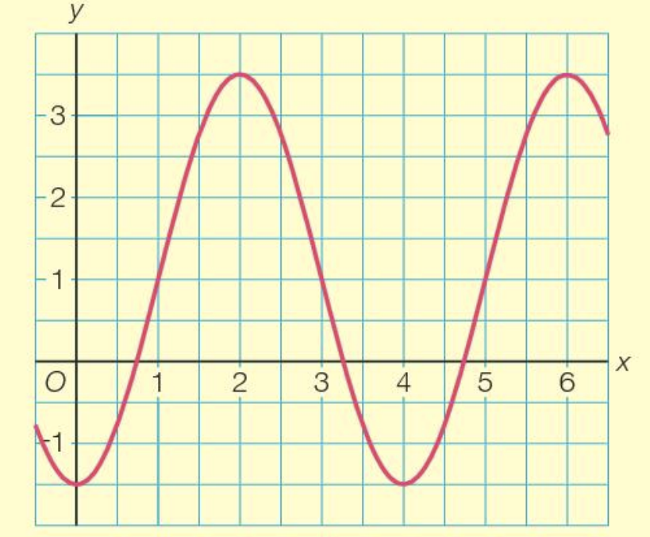 | $y=a+b sin(c\left(x-d\right))$ met $b<0$
2 |  | $y=a+b\cos{(c\left(x-d\right))}$ met $b<0$
3 | 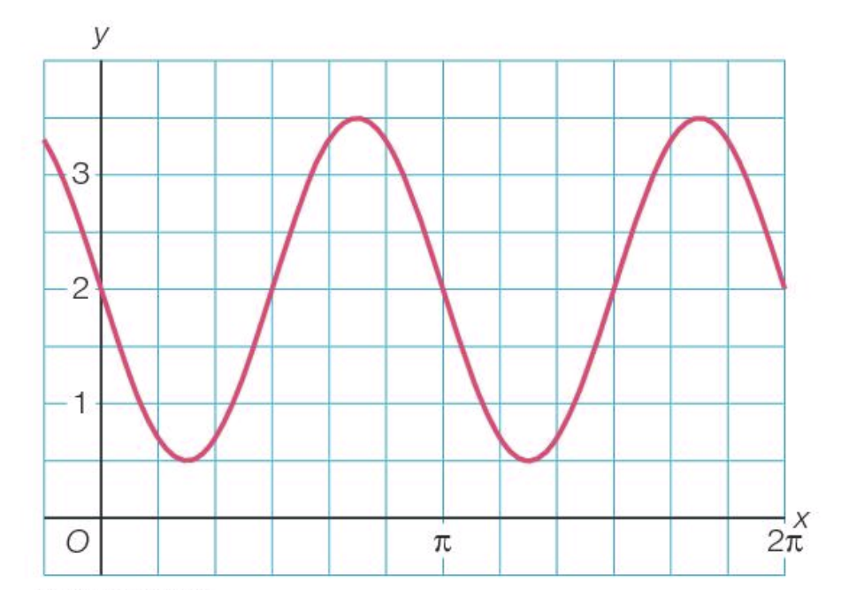 | $y=a+b sin(c\left(x-d\right))$ met $b>0$
4 |  | $y=a+b\cos{(c\left(x-d\right))}$ met $b>0$
5 | 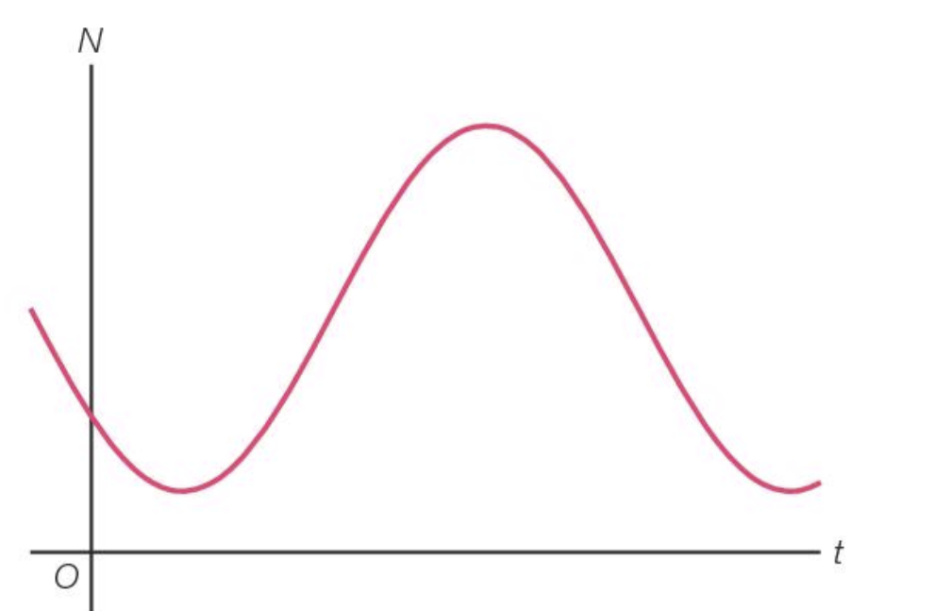 | $N=a+b sin(c\left(t-d\right))$ met $b>0$
6 |  | $N=a+b\cos{(c\left(t-d\right))}$ met $b>0$
7 | 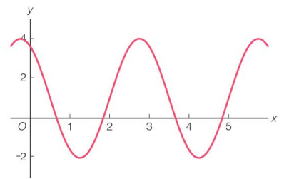 | $y=a+b sin(c\left(x-d\right))$ met $b>0$
8 |  | $y=a+b sin(c\left(x-d\right))$ met $b<0$

Opgave |  | Antwoord | Kleur | Nr
1 |  | $$y=1-2\frac{1}{2}sin\left(\frac{1}{2}π\left(x-3\right)\right)$$ |  | 5
2 |  | $$y=1-2\frac{1}{2}cos\left(\frac{1}{2}πx\right)$$ |  | 1
3 |  | $$y=2+1\frac{1}{2} sin\left(2\left(x-\frac{1}{2}π\right)\right)$$ |  | 7
4 |  | $$y=2+1\frac{1}{2} cos\left(2\left(x-\frac{3}{4}π\right)\right)$$ |  | 6
5 |  | $$N=100+75 sin\left(\frac{1}{5}π\left(t-4\right)\right)$$ |  | 13
6 |  | $$N=100+75 cos\left(\frac{1}{5}π\left(t-6\frac{1}{2}\right)\right)$$ |  | 10
7 |  | $$y=1+3 sin\left(\frac{2}{3}π\left(x-2\right)\right)$$ |  | 4
8 |  | $$y=1-3 sin\left(\frac{2}{3}π\left(x-\frac{1}{2}\right)\right)$$ |  | 3
Antwoordblad

1 | 1 | 1 | 1 | 1 | 1 | 1 | 1 | 1 | 1 | 1 | 1 | 1 | 1 | 1
6 | 11 | 11 | 11 | 11 | 11 | 11 | 11 | 11 | 11 | 11 | 11 | 11 | 11 | 6
6 | 2 | 8 | 8 | 8 | 8 | 8 | 10 | 8 | 8 | 8 | 8 | 8 | 2 | 6
6 | 2 | 8 | 9 | 9 | 9 | 10 | 10 | 10 | 9 | 9 | 9 | 8 | 2 | 6
6 | 2 | 8 | 11 | 11 | 11 | 11 | 7 | 11 | 11 | 11 | 11 | 8 | 2 | 6
6 | 2 | 8 | 12 | 12 | 12 | 7 | 7 | 7 | 12 | 12 | 12 | 8 | 2 | 6
6 | 2 | 8 | 12 | 12 | 4 | 4 | 4 | 1 | 4 | 12 | 12 | 8 | 2 | 6
6 | 2 | 8 | 15 | 4 | 4 | 5 | 4 | 4 | 4 | 4 | 15 | 8 | 2 | 6
6 | 2 | 8 | 15 | 15 | 3 | 3 | 3 | 5 | 3 | 15 | 15 | 8 | 2 | 6
6 | 2 | 8 | 15 | 3 | 1 | 3 | 3 | 3 | 3 | 3 | 15 | 8 | 2 | 6
6 | 2 | 8 | 9 | 9 | 4 | 4 | 4 | 1 | 4 | 9 | 9 | 8 | 2 | 6
6 | 2 | 8 | 9 | 4 | 4 | 5 | 4 | 4 | 4 | 4 | 9 | 8 | 2 | 6
6 | 2 | 8 | 7 | 7 | 7 | 7 | 7 | 7 | 7 | 7 | 7 | 8 | 2 | 6
6 | 2 | 8 | 14 | 14 | 14 | 14 | 13 | 14 | 14 | 14 | 14 | 8 | 2 | 6
6 | 2 | 8 | 8 | 8 | 8 | 8 | 13 | 8 | 8 | 8 | 8 | 8 | 2 | 6
1 | 1 | 1 | 1 | 1 | 1 | 1 | 1 | 1 | 1 | 1 | 1 | 1 | 1 | 1

1 | 1 | 1 | 1 | 1 | 1 | 1 | 1 | 1 | 1 | 1 | 1 | 1 | 1 | 1
6 | 11 | 11 | 11 | 11 | 11 | 11 | 11 | 11 | 11 | 11 | 11 | 11 | 11 | 6
6 | 2 | 8 | 8 | 8 | 8 | 8 | 10 | 8 | 8 | 8 | 8 | 8 | 2 | 6
6 | 2 | 8 | 9 | 9 | 9 | 10 | 10 | 10 | 9 | 9 | 9 | 8 | 2 | 6
6 | 2 | 8 | 11 | 11 | 11 | 11 | 7 | 11 | 11 | 11 | 11 | 8 | 2 | 6
6 | 2 | 8 | 12 | 12 | 12 | 7 | 7 | 7 | 12 | 12 | 12 | 8 | 2 | 6
6 | 2 | 8 | 12 | 12 | 4 | 4 | 4 | 1 | 4 | 12 | 12 | 8 | 2 | 6
6 | 2 | 8 | 15 | 4 | 4 | 5 | 4 | 4 | 4 | 4 | 15 | 8 | 2 | 6
6 | 2 | 8 | 15 | 15 | 3 | 3 | 3 | 5 | 3 | 15 | 15 | 8 | 2 | 6
6 | 2 | 8 | 15 | 3 | 1 | 3 | 3 | 3 | 3 | 3 | 15 | 8 | 2 | 6
6 | 2 | 8 | 9 | 9 | 4 | 4 | 4 | 1 | 4 | 9 | 9 | 8 | 2 | 6
6 | 2 | 8 | 9 | 4 | 4 | 5 | 4 | 4 | 4 | 4 | 9 | 8 | 2 | 6
6 | 2 | 8 | 7 | 7 | 7 | 7 | 7 | 7 | 7 | 7 | 7 | 8 | 2 | 6
6 | 2 | 8 | 14 | 14 | 14 | 14 | 13 | 14 | 14 | 14 | 14 | 8 | 2 | 6
6 | 2 | 8 | 8 | 8 | 8 | 8 | 13 | 8 | 8 | 8 | 8 | 8 | 2 | 6
1 | 1 | 1 | 1 | 1 | 1 | 1 | 1 | 1 | 1 | 1 | 1 | 1 | 1 | 1

1 | 1 | 1 | 1 | 1 | 1 | 1 | 1 | 1 | 1 | 1 | 1 | 1 | 1 | 1
6 | 11 | 11 | 11 | 11 | 11 | 11 | 11 | 11 | 11 | 11 | 11 | 11 | 11 | 6
6 | 2 | 8 | 8 | 8 | 8 | 8 | 10 | 8 | 8 | 8 | 8 | 8 | 2 | 6
6 | 2 | 8 | 9 | 9 | 9 | 10 | 10 | 10 | 9 | 9 | 9 | 8 | 2 | 6
6 | 2 | 8 | 11 | 11 | 11 | 11 | 7 | 11 | 11 | 11 | 11 | 8 | 2 | 6
6 | 2 | 8 | 12 | 12 | 12 | 7 | 7 | 7 | 12 | 12 | 12 | 8 | 2 | 6
6 | 2 | 8 | 12 | 12 | 4 | 4 | 4 | 1 | 4 | 12 | 12 | 8 | 2 | 6
6 | 2 | 8 | 15 | 4 | 4 | 5 | 4 | 4 | 4 | 4 | 15 | 8 | 2 | 6
6 | 2 | 8 | 15 | 15 | 3 | 3 | 3 | 5 | 3 | 15 | 15 | 8 | 2 | 6
6 | 2 | 8 | 15 | 3 | 1 | 3 | 3 | 3 | 3 | 3 | 15 | 8 | 2 | 6
6 | 2 | 8 | 9 | 9 | 4 | 4 | 4 | 1 | 4 | 9 | 9 | 8 | 2 | 6
6 | 2 | 8 | 9 | 4 | 4 | 5 | 4 | 4 | 4 | 4 | 9 | 8 | 2 | 6
6 | 2 | 8 | 7 | 7 | 7 | 7 | 7 | 7 | 7 | 7 | 7 | 8 | 2 | 6
6 | 2 | 8 | 14 | 14 | 14 | 14 | 13 | 14 | 14 | 14 | 14 | 8 | 2 | 6
6 | 2 | 8 | 8 | 8 | 8 | 8 | 13 | 8 | 8 | 8 | 8 | 8 | 2 | 6
1 | 1 | 1 | 1 | 1 | 1 | 1 | 1 | 1 | 1 | 1 | 1 | 1 | 1 | 1

