Opgave | Differentieer en herleid | Kleur | Nummer
1 | $$f\left(x\right)=-2{\left(2x+1\right)}^{4}$$
2 | $$g\left(x\right)=-\frac{6}{{(x^{2}+3x)}^{3}}$$
3 | $$h\left(x\right)=\frac{1}{\sqrt{4x-1}}$$
4 | $$f\left(x\right)=\frac{1}{{(3x-2)}^{2}}$$
5 | $$g\left(x\right)=(x^{2}+3)\sqrt{x^{2}+3}$$
6 | $$h\left(x\right)=\sqrt[3]{x^{3}+3x}$$
7 | $$k\left(x\right)=\sqrt{2x^{2}+4x}$$
8 | $$f\left(x\right)=5\sqrt{{2x}^{4}+x^{2}}+4x^{2}$$
9 | $$k\left(x\right)=\frac{1}{(4-x)\sqrt{4-x}}$$
10 | $$g\left(x\right)=\frac{x^{2}+4}{\sqrt{x^{2}+4}}$$
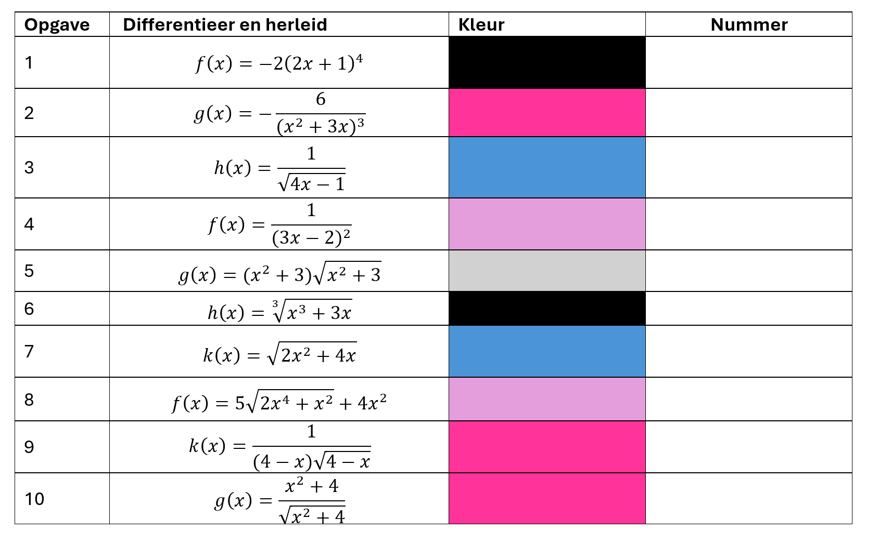

Antwoordblad

Opgave | Differentieer en herleid | Kleur | Nummer | Antwoord
1 | $$f\left(x\right)=-2{\left(2x+1\right)}^{4}$$ |  | 5 | $$f^{'}\left(x\right)=-16{(2x+1)}^{3}$$
2 | $$g\left(x\right)=-\frac{6}{{(x^{2}+3x)}^{3}}$$ |  | 3 | $$g^{'}\left(x\right)=\frac{18(2x+3)}{{(x^{2}+3x)}^{4}}$$
3 | $$h\left(x\right)=\frac{1}{\sqrt{4x-1}}$$ |  | 1 | $$h^{'}\left(x\right)=\frac{-2}{(4x-1)\sqrt{4x-1}}$$
4 | $$f\left(x\right)=\frac{1}{{(3x-2)}^{2}}$$ |  | 12 | $$f^{'}\left(x\right)=\frac{-6}{{(3x-2)}^{3}}$$
5 | $$g\left(x\right)=(x^{2}+3)\sqrt{x^{2}+3}$$ |  | 7 | $$g^{'}\left(x\right)=3x\sqrt{x^{2}+3}$$
6 | $$h\left(x\right)=\sqrt[3]{x^{3}+3x}$$ |  | 6 | $$h^{'}\left(x\right)=\frac{x^{2}+1}{\sqrt[3]{{(x^{3}+3x)}^{2}}}$$
7 | $$k\left(x\right)=\sqrt{2x^{2}+4x}$$ |  | 10 | $$k^{'}\left(x\right)=\frac{2x+2}{\sqrt{2x^{2}+4x}}$$
8 | $$f\left(x\right)=5\sqrt{{2x}^{4}+x^{2}}+4x^{2}$$ |  | 11 | $$f^{'}\left(x\right)=\frac{5(4x^{3}+x)}{\sqrt{2x^{4}+x^{2}}}+8x$$
9 | $$k\left(x\right)=\frac{1}{(4-x)\sqrt{4-x}}$$ |  | 20 | $$k^{'}\left(x\right)=\frac{3}{2{(4-x)}^{2}\sqrt{4-x}}$$
10 | $$g\left(x\right)=\frac{x^{2}+4}{\sqrt{x^{2}+4}}$$ |  | 2 | $$g^{'}\left(x\right)=\frac{x}{\sqrt{x^{2}+4}}$$

⁴ | ⁴ | ⁴ | ⁴ | ⁹ | ⁹ | ⁹ | ⁹ | ⁹ | ⁹ | ⁹
⁴ | ⁴ | ⁴ | ⁴ | ¹³ | ²⁰ | ²⁰ | ²⁰ | ⁹ | ⁹ | ⁹
¹³ | ¹³ | ¹³ | ¹³ | ²⁰ | ²⁰ | ⁵ | ²⁰ | ⁷ | ⁷ | ⁹
¹³ | ¹³ | ¹³ | ¹³ | ²⁰ | ²⁰ | ²⁰ | ²⁰ | ⁷ | ⁶ | ⁹
¹⁵ | ¹⁵ | ¹⁵ | ¹⁵ | ²⁰ | ²⁰ | ¹⁶ | ¹⁶ | ⁶ | ⁶ | ⁹
¹⁵ | ¹⁵ | ¹⁵ | ¹⁵ | ¹⁵ | ² | ² | ¹⁶ | ⁶ | ⁹ | ⁹
¹⁵ | ¹⁵ | ¹⁵ | ¹⁵ | ¹⁵ | ² | ² | ² | ¹⁷ | ¹⁷ | ¹⁷
⁸ | ⁸ | ⁸ | ⁸ | ² | ² | ² | ² | ² | ¹⁷ | ¹⁷
⁸ | ⁸ | ⁸ | ² | ² | ² | ² | ² | ² | ¹⁷ | ¹⁷
⁸ | ⁸ | ³ | ³ | ³ | ³ | ³ | ³ | ¹⁶ | ¹⁶ | ¹⁶
⁸ | ³ | ³ | ³ | ³ | ³ | ³ | ⁴ | ⁴ | ⁴ | ⁴
⁸ | ³ | ³ | ⁴ | ¹² | ⁴ | ¹¹ | ⁴ | ⁴ | ⁴ | ⁴
¹⁰ | ³ | ¹⁰ | ¹⁰ | ¹² | ¹⁰ | ¹¹ | ¹⁰ | ¹⁰ | ¹⁰ | ¹⁰
¹ | ¹ | ¹ | ¹ | ¹² | ¹ | ¹¹ | ¹ | ¹ | ¹ | ¹

