Opgavenblad

Opgave | Los algebraïsch op | Kleur | Nummer
1 | 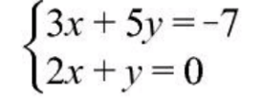
2 | 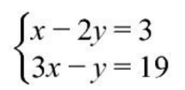
3 | 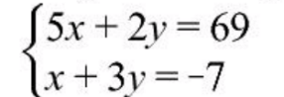
4 | 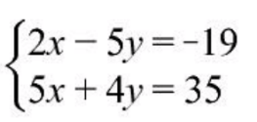
5 | 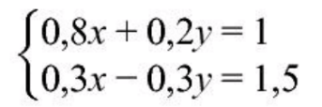
6 | 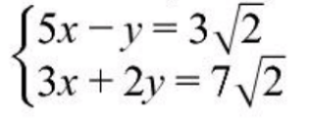
7 | 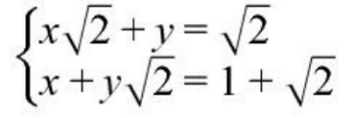
8 | 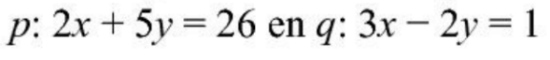  Bereken exact de coördinaten van het snijpunt van de lijnen

Opgave | Los algebraïsch op | Kleur | Nummer | Antwoord
1 |  |  | 2 | $$\left(x,y\right)=(1,-2)$$
2 |  |  | 5 | $$\left(x,y\right)=(7, 2)$$
3 |  |  | 3 | $$\left(x,y\right)=(17,-8)$$
4 |  |  | 8 | $$\left(x,y\right)=(3, 5)$$
5 |  |  | 7 | $$\left(x,y\right)=(2,-3)$$
6 |  |  | 4 | $$\left(x,y\right)=(\sqrt{2},2\sqrt{2})$$
7 |  |  | 10 | $$\left(x,y\right)=(1-\sqrt{2},2)$$
8 | Bereken exact de coördinaten van het snijpunt van de lijnen |  | 13 | Het snijpunt is  $$(3, 4)$$
Antwoordblad

¹ | ¹ | ¹ | ¹ | ¹ | ¹ | ¹ | ¹ | ¹ | ¹ | ¹ | ¹ | ¹ | ¹ | ¹ | ¹
¹ | ⁹ | ⁹ | ⁹ | ⁹ | ⁹ | ² | ² | ² | ² | ⁹ | ⁹ | ⁹ | ⁹ | ⁹ | ¹
¹ | ⁹ | ⁹ | ⁹ | ⁹ | ⁴ | ⁵ | ⁵ | ⁵ | ⁵ | ⁴ | ⁹ | ⁹ | ⁹ | ⁹ | ¹
¹ | ¹¹ | ¹⁵ | ¹⁵ | ⁴ | ⁵ | ⁵ | ⁵ | ⁵ | ⁵ | ⁵ | ⁴ | ¹⁵ | ¹⁵ | ¹¹ | ¹
¹ | ¹¹ | ¹⁵ | ¹⁵ | ⁴ | ¹³ | ¹³ | ¹³ | ¹³ | ¹³ | ¹³ | ⁴ | ¹⁵ | ¹⁵ | ¹¹ | ¹
¹ | ¹¹ | ¹⁵ | ⁴ | ⁷ | ¹³ | ¹³ | ¹³ | ¹³ | ¹³ | ¹³ | ⁷ | ⁴ | ¹⁵ | ¹¹ | ¹
¹ | ¹¹ | ¹⁵ | ⁴ | ⁷ | ⁹ | ³ | ¹³ | ¹³ | ⁹ | ³ | ⁷ | ⁴ | ¹⁵ | ¹¹ | ¹
¹ | ¹¹ | ¹⁵ | ⁴ | ⁷ | ³ | ³ | ¹³ | ¹³ | ³ | ³ | ⁷ | ⁴ | ¹⁵ | ¹¹ | ¹
¹ | ¹¹ | ⁴ | ⁵ | ⁷ | ⁷ | ⁸ | ⁸ | ⁸ | ⁸ | ⁷ | ⁷ | ⁵ | ⁴ | ¹¹ | ¹
¹ | ¹¹ | ⁴ | ⁵ | ⁷ | ⁶ | ⁶ | ⁸ | ⁸ | ⁶ | ⁶ | ⁷ | ⁵ | ⁴ | ¹¹ | ¹
¹ | ¹¹ | ⁴ | ⁵ | ³ | ⁶ | ⁶ | ⁶ | ⁶ | ⁶ | ⁶ | ³ | ⁵ | ⁴ | ¹¹ | ¹
¹ | ¹¹ | ¹⁵ | ³ | ³ | ⁶ | ⁶ | ⁶ | ⁶ | ⁶ | ⁶ | ³ | ³ | ¹⁵ | ¹¹ | ¹
¹ | ¹¹ | ¹⁵ | ¹⁵ | ³ | ¹⁰ | ¹⁰ | ⁴ | ⁴ | ¹⁰ | ¹⁰ | ³ | ¹⁵ | ¹⁵ | ¹¹ | ¹
¹ | ¹¹ | ¹⁵ | ¹⁵ | ¹⁵ | ² | ² | ⁹ | ⁹ | ² | ² | ¹⁵ | ¹⁵ | ¹⁵ | ¹¹ | ¹
¹ | ¹ | ¹ | ¹ | ¹ | ¹ | ¹ | ¹ | ¹ | ¹ | ¹ | ¹ | ¹ | ¹ | ¹ | ¹

